### RENTIGO

### (CAR RENTAL SYSTEM)

A PROJECT REPORT SUBMITTED IN PARTIAL FULFILMENT OF REQUIREMENT

FOR THE AWARD OF THE DEGREE

**BACHELOR OF COMPUTER APPLICATIONS (BCA)**

**OF**

**MAHATMA GANDHI UNIVERSITY, KOTTAYAM**

**BY**

ABHIJITH SANKAR 190021090696

ABIL SAIKUMAR 190021090699

ZENOY PETER 190021090743

JOSHUA SHAJI 190021090724



**Yeldo Mar Baselios College, Kothamangalam**

**Puthuppady, Kerala – 686691**

**February 2022**

### RENTIGO

### (CAR RENTAL SYSTEM)

A PROJECT REPORT SUBMITTED IN PARTIAL FULFILMENT OF REQUIREMENT

FOR THE AWARD OF THE DEGREE

**BACHELOR OF COMPUTER APPLICATIONS (BCA)**

**OF**

**MAHATMA GANDHI UNIVERSITY, KOTTAYAM**

**BY**

ABHIJITH SANKAR 190021090696

ABIL SAIKUMAR 190021090699

ZENOY PETER 190021090743

JOSHUA SHAJI 190021090724

Under the guidance of

##### MS. NIMMY N ABRAHAM

Assistant Professor

U G Department of Computer Applications

Yeldo Mar Baselios College Kothamangalam



**Yeldo Mar Baselios College, Kothamangalam**

**Puthuppady, Kerala – 686691**

**February 2022**

**UG DEPARTMENT OF COMPUTER APPLICATIONS**

**Yeldo Mar Baselios College**

**Kothamangalam**

**[MAHATMA GANDHI UNIVERSITY, KOTTAYAM]**

**PUTHUPPADY – 686691, KERALA.**

**CERTIFICATE**

This is to certify that the project work entitled

**“RENTIGO”**

is a bonafide record of work done by

ABHIJITH SANKAR 190021090696

ABIL SAIKUMAR 190021090699

ZENOY PETER 190021090743

JOSHUA SHAJI 190021090724

In partial fulfillment of the requirements for the award of Degree of

**BACHELOR OF COMPUTER APPLICATIONS [BCA]**

During the academic year 2021-2022.

**Ms. Nimmy N Abraham**

Assistant Professor

**Ms. Neethu M Mathew**

HOD

**Acknowledgement**

We are grateful to each and everyone who has contributed in numerous ways to the development of this project whose efforts had been a helping hand in every footstep towards my destiny.

We give all the glory and honour to the God Almighty, whose divine touch had been the foremost inspiration and guiding light in the fulfillment of this uphill task.

We are glad to present the project report entitled “RENTIGO” prepared as a part of our fifth semester Master of Computer Application course.

We take this opportunity to express my deep sense of gratitude and sincere thanks to our Principal **Prof. K.M George**, of Yeldo Mar Baselios College, Kothamangalam for giving us an opportunity to take up the project work.

We would like to express my gratitude to **Ms. Neethu M Mathew**, Head of the Department of Computer Application, who has served as a host of valuable corrections. It is wordless to say thanks to our internal **Ms. NIMMY N ABRAHAM** extend our sincere gratitude to all other lecturers in the Department of Computer Applications, who have contributed to complete our project.

We extremely thank our parents for their moral support and constant encouragement, which had always been a source of inspiration to us.

**Joshua Shaji**

**Zenoy Peter**

**Abil Saikumar**

**Abhijith Sankar**

**ABSTRACT**

**INTRODUCTION:**

RentiGo provide car rental services to the users. It provide a separate platform for admin and customers. Through this web application customers can rent out their desired car . Users can easily book our services using our web application . The application also allow users to post their complaints and view solutions from the administrator. Customers get a complete freedom over their profile and choices. They can browse through our list of cars and choose to book it in a scheduled time and date. This system also provide a separate platform for admin also. Admin can login and work freely in this system . Admin can contact with customers though online chatting facility or mail and provide solution for their complaints

**MODULES**

There are 3 modules in our project

1. **ADMIN**

* Admin provide login with email and password.
* They manages all the rental cars
* They can add new rental cars.

**2) USER**

* User can login with their email and passwords details.
* They can search for Rental cars
* They can Book and view their Bookings.
* Payments are from owner to customer.
* They can enter their ratings, complaints and feedbacks
* They can subscribe to newsletter.

1. **HOTELS**

* Login
* Registration

|  |  |  |
| --- | --- | --- |
| **Serial no** | **Description** | **Page no** |
| **1.** | **Chapter 1: Introduction**   1. General Introduction 2. Objective of the Project 3. Data and Information 4. Tools Used | **8 – 9** |
| **2.** | **Chapter 2 : System Analysis**   1. Introduction 2. Existing System    * Limitation of Existing system 3. Proposed System    * Advantages of Proposed system 4. Feasibility Study    * Technical feasibility    * Operational feasibility    * Economic feasibility | **10 – 11** |
| **3.** | **Chapter 3 :**  **Feasibility Study**   1. Technical feasibility 2. Operational feasibility 3. Economic feasibility | **12 – 13** |

|  |  |  |
| --- | --- | --- |
| **4.** | **Chapter 4 : Software Requirement Specification**   1. Introduction 2. Functional Requirements 3. Non - Functional Requirements 4. Software Requirement Specification 5. Hardware Requirement Specification 6. Tools and Platforms | **14 - 19** |

|  |  |  |
| --- | --- | --- |
| **5.** | **Chapter 5 : SYSTEM DESIGN**   1. MODULE SPECIFICATION 2. INPUT DESIGN 3. DATABASE DESIGN 4. UML DIAGRAM 5. TABLE DESIGN | **20 – 30** |
| **6.** | **Chapter 6 : System Testing**   1. Introduction 2. Integration Testing 3. System Testing 4. Test Plans & Test cases | **31 – 33** |
| **7.** | **Chapter 7: System Maintenance**   * Introduction * Maintenance | **34 – 35** |
| **8.** | **Chapter 8 : Future Enhancement and scope of further development**   1. Introduction 2. Merits of the system 3. Limitations of the system 4. Future Enhancement of the System | **36** |
| **9.** | **Chapter 9 : Conclusion** | **37** |
| **10.** | **Chapter 10 : Bibliography** | **38** |
| **11.** | **Chapter 11 : Appendix**  **and Screenshots** | **39 - 55** |

**CHAPTER 1 INTRODUCTION**

##### GENERAL INTRODUCTION

Nowadays, there is Online Car Rental which gives much benefit to user. A rental service is a service which customers arrive to request the hire of a rental unit. It is more convenient than carrying the cost of owning and maintain the unit. A car rental is a company that rent automobiles for short period of time for a fee for few hours or a few days or a week.

It helps to book the cars or vehicles online rather than using the traditional manual system of vehicle reservation. This eliminates the risk of erroneous booking and reduce overall lead time and ensures growth in customer satisfaction. They can book any car according to their brands and price.

##### OBJECTIVE OF THE PROJECT

##### 

The objective of the project is to automate vehicle rental ad reservation so that the customers do not need to call and spend unnecessary time to reserve a vehicle.

* To transform the manual process of hiring car to a computerize system
* To validate the Rental car system using user satisfaction test
* To produce the documentation such as Software Requirement Specification(SRS), Software Design Description as system development reference

##### DATA AND INFORMATION

Data collection plays an important role in a projects succession and also it plays an inevitable role in the timely completion of the project. The data in the project includes contact information of the clients and their respective feedbacks/complaints which is stored in a database. To assure safety, only the admin has proper access to the information provided by the clients.

##### TOOLS USED

* **Xampp:**
  + **Apache:**
    - (Application Server) Apache , often referred to as Server, is an open-source Java Servlet Container developed by the Apache Software Foundation.
  + **MySqlServer:** 
    - It handles larege databases much faster than existing solutions.
    - It consists of multi-threaded SQL server that supports different back ends, several different client programs and libraries, administrative tools, and application programming interfaces (APIs)
    - Its connectivity, speed, and security make MySQL Server highly suited for accessing databases on the Internet.
* **Sublime Text 3.1.1-** Sublime Text is a sophisticated text editor for code, markup and prose. You'll love the slick user interface, extraordinary features and amazing performance.
* **Web browsers**: Google Chrome,Mozilla Firefox, Opera and Internet Explorer.

**CHAPTER 2 SYSTEM ANALYSIS**

* 1. **INTRODUCTION**

System Analysis is a structured process identifying and solving problems. The performance, management and documentation of the activities related to the four phases of the life cycle of a business information system.

Analysis involves the requirement determination and specifications. Basically it involves establishing for all the system elements and then mapping these requirements to the software form. The analysis is intended to capture and describe all the requirements of the system and to make a model that defines a key domain classes in the system. The purpose is to provide an understanding and to enable a communication about the system between the developers and the people establishing the requirements. Therefore the analysis is typically terms of code or programs during this phase. It is the first step towards really understanding the requirements.

##### EXISTING SYSTEM

Now most of the existing system works manually. Data stored are entered on a register book makes data manipulation difficult and takes a lot of human effort. It requires lot of time for checking details and detailed information may not available. As it done through manually, the system create many confusions and imperfections. So we can say that the existing system is simply wastage of time.

##### LIMITATIONS OF EXISTING SYSTEM

* + - * Difficult in data recording
      * Less efficient
      * Inadequate
      * Requires lot human effort
      * Updating, deletion and insertion is difficult
      * Searching of details require lot of time

##### PROPOSED SYSTEM

The proposed system is very efficient as compare to the existing system. The proposed system overcomes many limitations of existing system by providing rental vehicles to all common people.

Here the users can view products and confirm their needs and even can view product’s details, reviews by the others users. It is fully computerized, by this user will be able to book and cancel their vehicles according to their needs .The system creates a convenience to both users and admin.

##### ADVANTAGES OF PROPOSED SYSTEM

* + - * Store all type of data in database using DBMS.
      * Easy data manipulation.
      * Data access only to the authorized people
      * Ensure valid and error free data entry user friendly
      * Provides more security by using password

**CHAPTER 3 FEASIBILITY STUDY**

In any Project, feasibility analysis is a very important stage, here the project is checked for its feasibility. Any project may face scarcity in resources, time or work force. Hence all these are to be studied in detail and a conclusion should be drawn whether the project under consideration is feasible or not. This analysis is a test of the proposed project, regarding its workability, impact on users and clients and resources management. Feasibility and risk involved are inversely related to each other. The main objective of feasibility is to test technical, operational and economic feasibility of a project.

* 1. **Technical Feasibility**

Technical Feasibility centers around the existing computer system and do what extend it can support the proposed addition. Technical considerations evaluate existing hardware and software. This involves financial considerations to accommodate technical enhancements. Evaluating the technical feasibility is the trickiest part of a feasibility study. This is because, at this point in time, not too many detailed design of the system, making it difficult to access issue like performance, cost, etc. A number of issues have to be considered while doing a technical analysis.

* 1. **Operational Feasibility**

Operational Feasibility is considered with the working of the system after its installation. This system can be installed in the client environment and the developers will help in the maintenance of the system in future. Proposed projects are beneficial only if they can be turned into information system that will meet the organization’s operating requirements, this test of feasibility asks if the system will work when it is developed and installed.

* 1. **Economic Feasibility**

Economic analysis is the most frequent used method for evaluating the effectiveness of the system. Economic analysis determines whether the adoption of a system can be cost justified. More commonly known as cost benefit analysis, the procedure is to determine the benefits and compares them with costs. A simple economic analysis which gives the actual comparison of the cost and benefits are much meaningful in this case. It benefits outweigh costs, and then the decision is made to design and implement the system, Otherwise, further justifications or alternations in the proposed system will have to made if it is to have a change of being approved.

**CHAPTER 4 SOFTWARE REQUIREMENT SPECIFICATION**

* 1. **INTRODUCTION**

The system environments with regard to an application project are the environments which shaped the flesh and bones of the system from the concepts and ideas to a real working model. It is so crucial in selecting the various environments for the system development since they plays a vital role in determining the properties and behaviour of the system. The overall project development is associated with the system environment selected. So the system environment should be selected such that the project development becomes smooth and easy. So a detailed study should be conducted and proper system environment should be selected. Basically the system environment is divided into Software Configuration and Hardware Configuration.

There is no a clear distinction between functional and non-functional requirements. Whether or not a requirement is expressed as a functional or a non-functional requirement may depend:

* On the level of detail to be included in the requirements document
* The comprehension of application domain and the desired system experience of developers.

Some properties of a system may be expressed either as a functional or non-functional property. Example The system shall ensure that data is protected from unauthorized access. Conventionally a non-functional requirement (security) because it does not specify specific system functionality expressed as functional requirement: The system shall include a user authorization procedure where users must identify themselves using a login name and password. Only users who are authorized in this way may access the system data. Non-functional requirements may result in new functional requirements statements.

* 1. **Functional Requirements**

**Valid Registration**

To access the functionalities of tis system users want to register into the system.They can login into the system with valid information. Only approved users can login into the system.

**Message Management**

The messages should be stored actually in the mail server. Messages should be received only to registerd user

* 1. **Non-Functional Requirements**

**Performance**

It provides better performance than existing system. Because Its main concern is to help the visually challenged to access their mails and reply to them. This project enables smooth and reliable management of mails for a visually challenged person.Here the message converting the texts to speech (audible form) with the help of speech synthesizer. This enables the blind person to access mails and hear the contents of the mail. The project is also concerned with converting the speech to text with the help of the speech recognizer. This enables the blind to reply to his/her mails by speaking into a microphone.

**Availability**

Availability is the proportion of time a system is in a functioning condition. Here the system is always available.

**Portablty**

Portability in high-level computer programming is the usability of the same software in different environments. Since it is a web application it can be implemented in different environments.

**Security**

The security is maintained by making use of the user’s finger print. The admin is the one who grand the permission to access the system.

**Maintainablity**

The system shall provide the capability to backup the database. In this system the language English, can only be recognised. In future, we can extent the system by including more languages and can recognise more languages.

**Reliablity**

The system shall be available 99.9% of time

##### 4.4 SOFTWARE REQUIREMENT SPECIFICATION

The system requirement specification is a technical specification of requirement for the product. The goal of the system requirement definition is to completely specify the technical requirements for the software product in a concise and unambiguous manner. A software requirements specification (SRS) is a description of a software system to be developed. It lays out functional and non-functional requirements, and may include a set of use cases that describe user interactions that the software must provide Software requirements .

Operating system : Microsoft Windows XP / above Platform : Visual Studio 2012

Front End : PHP

Back End : MYSQL Server

The application must inform the user with proper message when there is an error in data entry or when an activity is successfully completed

##### 4.5 HARDWARE REQUIREMENT SPECIFICATION

This describes the logical and physical characteristics of each interface between the software product and hardware components of the system.

Processor : Intel Pentium Dual Core / above Hard Disk Space : 80 GB or more

Ram : 1GB or more so that data access can be made faster.

Display : 14.1 Color Monitor (LCD, CRT or LED)

Clock Speed : 2.24 GHz

##### TOOLS, PLATFORM

The front end tool used is PHP and back end tool used is My SQl. PHP is a scripting language.

##### FRONT END TOOL

PHP [1] is a dynamically typed general purpose scripting language which can be embedded in HTML pages. It was designed in 1995 for implementing dynamic web pages, its name initially standing for Personal Home Pages. PHP now stands for the recursive acronym PHP: Hypertext Preprocessor. While predominantly used for server- side scripting PHP can be used for writing command line scripts and client-side GUI applications. It may also be embedded into host applications to provide them with scripting functionality. The main implementation of PHP is free open source software. This provides the de facto definition of the syntax and semantics for the language since there is no formal specification. While the end user interface and extensions API for the PHP interpreter are well documented [2, 10], scant documentation exists for the internals of the parser and the Zend engine (which interprets scripts). The lexical analyser is defined using a Flex description of 2000 lines, and the parser a Bison specification of 900 lines. It is difficult to extract any formal specification from either source file because of: unnecessary redundancy and poor structuring of the grammars; convoluted rules which attempt to enforce static checks; embedded semantic actions trying to ensure associativity is appropriately maintained at certain points during parsing; and the requirement for tight coupling between the lexical analyser and parser due to in-string syntax which is not amenable to processing using the traditional lexical analysis and parser interface.

##### BACK END TOOL

**MS-SQL SERVER**

Microsoft SQL Server features include:

* + - * Internet Integration.
      * The SQL Server 2008 database engine includes integrated XM support. It has the scalability, availability, and security features required to operate as the data storage component of the largest Web sites.
      * Scalability and Availability.
      * The same database engine can be used across platforms ranging from laptop computers running Microsoft Windows 98 through large, multiprocessor servers running Microsoft Windows 2008 Data Center Edition. SQL Server 2008 Enterprise Edition supports features such as federated servers, indexed views, and large memory support that allow it to scale to the performance levels required by the largest Web sites.
      * Enterprise-Level Database Features
      * The SQL Server 2008 relational database engine supports the features required to support demanding data processing environments .The database engine protects data integrity while minimizing the overhead of managing thousands of users concurrently modifying the database.
      * Ease of installation, deployment, and use
      * SQL Server 2008 includes a set of administrative and development tools that improve upon the process of installing, deploying, managing and using SQL

Server across several sites. SQL Server 2008 also supports a standards- base programming model integrated with the Windows DNA, making the use of SQL Server databases and data warehouses a seamless part of building powerful and scalable systems.

* + - * Data Warehousing
      * SQL Server 2008 includes tools for extracting and analyzing summary data for online analytical processing .SQL Server also includes tools for visually designing databases and analyzing data using English-based questions.

**Advantages of SQL Server 2008 as a Database Server**

Microsoft SQL Server 2008 is capable of supplying the database services needed by extremely large systems. Large servers may have thousands of users connected to an instance of SQL Server 2008 at the same time. SQL Server 2008 has full protection for these environments, with safeguards that prevent problems, such as having multiple users trying to update the same piece of data at the same time. SQL Server 2008 also allocates the available resources effectively, such as memory, network bandwidth, and disk I/O, among the multiple users.

Extremely large Internet sites can partition their data across multiple servers, spreading the processing load across many computers, and allowing the site to serve thousands of concurrent users. Multiple instances of SQL Server 2008 can be run on a single computer. SQL Server 2008 applications can run on the same computer as SQL Server 2008.

.

**Information Representation**

In SQL Server, data is represented in terms of rows and columns of a table. Data stored as a table can be easily visualized.

Unique definition of rows

In SQL Server we can make each row of a table unique by using a feature called constraints.

**Guaranteed access**

In SQL Server, a data that is stored across tables in one or more database can be combined using query.

**Systematic treatment of null values**

SQL Server like most RDBMS treats Null values, zeroes and blanks differently. While creating a table, one can specify whether a field allow Null values or not.

**High level update, insert and delete**

In SQL Server if a record is updated or deleted in Master table, the corresponding record in the table is also updated or dropped.

**Features of SQL Server 2008**

Manage any data, any place, and any time. 18. Store data from structured, semi structured, and unstructured documents, such as images, and rich media, directly within the database. 19. SQL SERVER 2008 delivers a rich set of integrated services that enable to do more with data such as query, search, synchronize, report and analyze. 20. Easy installation: SQL SERVER 2008 provides a set of administrative and development tools for easy installation, deployment, and management. 21.

Integration with internet : SQL SERVER has a database engine which is a core integral part of the RDBMS and stores data in a table. 22. Scalability and Availability. 23. Support for client/server Model: SQL SERVER is designed to follow the client/server model. 24. Operating System Compatibility: Since SQL SERVER 2008 is Microsoft product, it is compatible with windows NT Server 4, Windows 2000, Windows 7, Windows XP etc. 25. Business service: This layer is known as application server tier, which is layer between the user interface and database. 26. Data Services: This layer deals with interacting with the actual data source. The four functional areas in a data service layer are: retrieving data, inserting data, updating data and deleting data.

**CHAPTER 5 SYSTEM DESIGN**

**SYSTEM DESIGN**

The goal of design process is to produce a model or a representation of a moving from the problem domain to the solution domain .In top level design focus is on deciding which modules are needed for the system, the specification of these modules and how these modules can be interconnected. In this project design technique used is top-down, object- oriented dynamic modelling technique. A top-down design approach starts by identifying the major components and iterating until the desired level of details is achieved. In object oriented design technique, the modules in the design represent data abstraction. A dynamic model aim to specify new the state of various objects changes as events occur.

**MODULE SPECIFICATION**

There are 3 modules in our project

1. **ADMIN**

* Admin provide login with email and password.
* They manages all the rental cars
* They can add new rental cars.

**2) USER**

* User can login with their email and passwords details.
* They can search for Rental cars
* They can Book and view their Bookings.
* Payments are from owner to customer.
* They can enter their ratings, complaints and feedbacks
* They can subscribe to newsletter.

1. **HOTELS**

* Login
* Registration

**INPUT DESIGN**

Inaccurate input data is the most cause of errors indata processing. Errors by data entry operators can becontrolled by input validation. Input design is the processof converting user-oriented inputs to a computer-basedformat. Input design is a part of an overall system design, which makes the system user friendly. The input design is the link between the information system and users. It comprises developing specification and those steps that are necessary to put transaction data into a useable form for processing data entry. The activity of putting data into the computer for processing can be achieved by instructing the computer to read data from a written or printed document or it can occur by having people key data directly in to the system . The design of input focuses on controlling the amount of inputs required, controlling errors, avoiding delay, avoiding extra steps and System analyst decides the following input design:

a. What data to input.

b. What medium to use.

c. How the data should be arranged or coded.

**OUTPUT DESIGN**

Efficient and transport output design improves the system relationship with the user and help him to understand faster. A complicated output design contributes nothing to the system but leave the user confused. For a successful system it is a must that it maintains a clear output design. The users of the output its purpose and sequence of details to be printed are all considered. The output form is system is the justification for its existence. If the outputs are inadequate in a way the system itself is inadequate. The basic requirements of content medium and layout for its intended purpose. Hence it is necessary to design output is in the form of reports. Output design is process that in values designing necessary output in the form of reports that should be given to the users according to the requirements.

**Process Design**

A successful process design has to take into account the appropriateness of the process to overall organization objective. Process design requires a broad view of the whole organization and should not have a myopic outlook. And the process should deliver customer value with constant involvement of the management at various stages. In order to achieve a good process design, effective process strategy is required, which deals with a singular line items required to manufacture the end product. Effective process strategy deals with raw material procurement, customer participation, technology investment, etc. Over a period of time process design has undergone change and new concepts like Flexible Manufacturing Systems have been developed, which delivers efficient and effective production design and analysis.

**DATABASE DESIGN**

Database design can be generally defined as a collection of tasks or processes that enhance the designing, development, implementation, and maintenance of enterprise data management system. Designing a proper database reduces the maintenance cost thereby improving data consistency and the cost-effective measures are greatly influenced in terms of disk storage space. Therefore, there has to be a brilliant concept of designing a database. The designer should follow the constraints and decide how the elements correlate and what kind of data must be stored.

The main objectives behind database designing are to produce physical and logical design models of the proposed database system. To elaborate this, the logical model is primarily concentrated on the requirements of data and the considerations must be made in terms of monolithic considerations and hence the stored physical data must be stored independent of the physical conditions. On the other hand, the physical database design model includes a translation of the logical design model of the database by keep control of physical media using hardware resources and software systems such as Database Management System (DBMS)

**DFD FOR** **RENTIGO**

##### 

**DFD FOR** **LOGIN**

##### 

##### 

**UML DIAGRAM**

##### 1.PNG

**FLOW CHART**

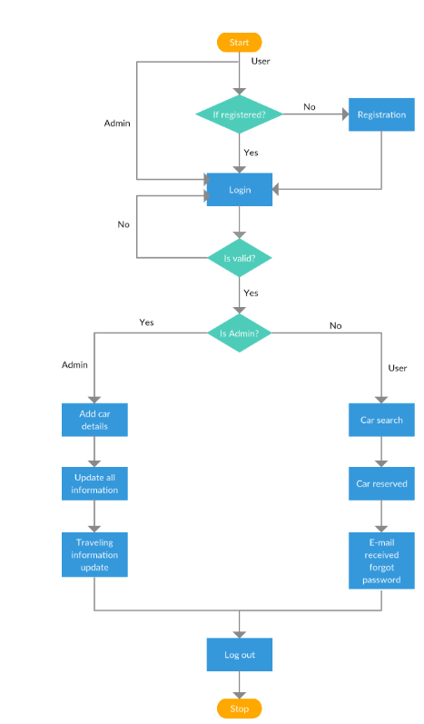

**TABLE DESIGN**

TABLE ADMIN

|  |  |  |
| --- | --- | --- |
| Fieldname | Datatype | Constraints |
| id | int(11) | not null primarykey |
| username | varchar(100) | not null |
| password | varchar(100) | not null |

TABLE USER

|  |  |  |
| --- | --- | --- |
| Fieldname | Datatype | Constraints |
| id | int(11) | not null primarykey |
| Emailid | varchar(100) | not null |
| FullName | varchar(100) | not null |
| Password | varchar(100) | not null |
| ContactNo | char(11) | not null |
| dob | varchar(100) | not null |
| Address | varchar(100) | not null |
| City | varchar(100) | not null |
| Country | varchar(100) | not null |

TABLE BOOKING

|  |  |  |
| --- | --- | --- |
| Fieldname | Datatype | Constraints |
| id | int(11) | not null primarykey |
| userEmail | varchar(100) | not null |
| VehicleId | int(11) | not null |
| FromDate | varchar(100) | not null |
| ToDate | char(11) | not null |
| message | varchar(100) | not null |
| status | varchar(100) | not null |

TABLE BRANDS

|  |  |  |
| --- | --- | --- |
| Fieldname | Datatype | Constraints |
| id | int(11) | not null primarykey |
| BrandName | varchar(100) | not null |

TABLE CONTACT US INFO

|  |  |  |
| --- | --- | --- |
| Fieldname | Datatype | Constraints |
| Id | int(11) | not null primarykey |
| Address | varchar(100) | not null |
| EmailId | varchar(100) | not null |
| ContactNo | int(11) | not null |

TABLE CONTACT US QUERY

|  |  |  |
| --- | --- | --- |
| Fieldname | Datatype | Constraints |
| Id | int(11) | not null primarykey |
| Name | varchar(100) | not null |
| EmailId | varchar(100) | not null |
| ContactNo | int(11) | not null |
| Message | varchar(100) | not null |
| PostingDate | timestamp | not null |
| Status | varchar(100) | not null |

TABLE PAGES

|  |  |  |
| --- | --- | --- |
| Fieldname | Datatype | Constraints |
| Id | int(11) | not null primarykey |
| PageName | varchar(100) | not null |
| Type | varchar(100) | not null |
| Detail | longtext | not null |

TABLE SUBSCRIBERS

|  |  |  |
| --- | --- | --- |
| Fieldname | Datatype | Constraints |
| Id | int(11) | not null primarykey |
| SubscriberEmail | varchar(100) | not null |
| PostingDate | timestamp | not null |

TABLE TESTIMONIAL

|  |  |  |
| --- | --- | --- |
| Fieldname | Datatype | Constraints |
| Id | int(11) | not null primarykey |
| UserEmail | varchar(100) | not null |
| Testimonial | varchar(100) | not null |
| PostingDate | timestamp | not null |
| Status | varchar(100) | not null |

TABLE VEHICLES

|  |  |  |
| --- | --- | --- |
| Fieldname | Datatype | Constraints |
| id | int(11) | not null primarykey |
| VehicleTitle | varchar(100) | not null |
| VehicleBrand | varchar(100) | not null |
| VehicleOverview | varchar(100) | not null |
| PricePerDay | char(11) | not null |
| FuelType | varchar(100) | not null |
| ModelYear | varchar(100) | not null |
| SeatingCapacity | Int(11) | not null |
| Vimage1 | varchar(100) | not null |
| Vimage2 | varchar(100) | not null |
| Vimage3 | varchar(100) | not null |
| Vimage4 | varchar(100) | not null |
| Vimage5 | varchar(100) | not null |
| AirConditionar | Int(11) | not null |
| PowerDoorLocks | Int(11) | not null |
| ABS | Int(11) | not null |
| BrakeAssist | Int(11) | not null |
| PowerSteering | Int(11) | not null |
| DriverAirbag | Int(11) | not null |
| PassengerAirbag | Int(11) | not null |
| PowerWindow | Int(11) | not null |
| CDPlayer | Int(11) | not null |
| CentralLocking | Int(11) | not null |
| CrashSensor | Int(11) | not null |
| LeatherSeats | Int(11) | not null |
| RegDate | Timestamp | not null |
| UpdationDate | timestamp | not null |

**CHAPTER 6**

**SYSTEM TESTING**

* 1. **INTRODUCTION**

Software testing is a critical element of software quality assurance and represents the ultimate review of specification, design and coding, testing presence an interesting anomaly for the software engineer.

Testing Objectives include:

* + - Testing is a process of executing a program with the intent of finding an error.
    - A good test case is one that has a probability of finding an as yet undiscovered error.
    - A successful Test is one that uncovers an undiscovered error. Testing Principles:
    - All tests should be traceable to end user requirements.
    - Tests should be planned long before testing begins.
    - Testing should begin on a small scale and progress towards testing in large.
    - Exhaustive testing is not possible.

Testing phase of system development life cycle will tests system design. Testing of system decides whether the newly designed system works properly or not. After the development of documentation manually about the system this stage is checked. And if the system working properly then it will be considered for implementation and if isn’t then system analyst is informed to find out generated errors or problems and to find out its solutions. This process is known as debugging.

**Black Box Testing**

Black Box testing also called functional testing, focuses on the functional requirements of the software. Knowing the specified function that a product designs to perform the test can be conducted to ensure that each function is fully operational. Black Box tests are carried out to test that input to function is properly accepted and output is correctly produced. Black Box Testing treats the software as a black box without any knowledge of internal implementation.

For the proposed system the black box testing ensures the following requirements.

Menus are displayed correctly for each user The login checking is ensured. Black Box testing is used to detect errors of the type incorrect or missing functions, interface errors, errors in data structures or external data base access, initialization and termination errors. Black Box testing methods include: equivalence partitioning, Boundary value analysis and specification testing

**White Box Testing**

This type of testing is also called structural testing, involves checking the actual code following the control flow and ensuring the validity of the logic involved in the implementation. White Box Testing is when the tester has access to the internal data structures and algorithms including the code that implements these.

Testing was done on:

* + - Programming portion: For optimizing the speed of execution ,the unwanted portion of the code are removed
    - The structure of each and every web page of the system Test cases:
    - Execute each independent part of the code at least once.
    - Check validity of control statements and their boundary values
    - Check the validity of the data structures used Check the validity and the effectiveness of the table design

##### INTEGRATION TESTING

Through each program work individually, they should work after linking together. This is referred to as interfacing. Data may be lost across the interface; one module can have adverse effect on the other subroutines after linking may not do the desired function expected by the main routine. Integration testing is the systematic technique for constructing the program structure while at the same time conducting test to uncover errors associated with the interface. Using integrated test plan prepared in the design phase of the system development as a guide, the integration test was carried out. All the errors found in the system were corrected for the next testing step.

##### SYSTEM TESTING

System Testing is a level of the software testing where a complete and integrated software is tested. The purpose of this test is to evaluate the system's compliance with the specified requirements. System testing of software or hardware is testing conducted on a complete, integrated system to evaluate the system's compliance with its specified requirements. System testing falls within the scope of black-box testing, and as such, should require no knowledge of the inner design of the code or logic.

##### 6.3.1 TEST PLANNING AND CASES

A test plan is a document detailing the objectives, target market, internal beta team, and processes for a specific beta test for a software or hardware product. The plan typically contains a detailed understanding of the eventual workflow.

**Test Case 1**

LOGIN PAGE

Name of Form: Login

Objective : This page can be used for the login into system.

**Test Case 2**

Module Name : Admin Name of Form : login

Objective : This page can be used for login of administrator

##### CHAPTER 7

##### SYSTEM MAINTAINANCE

* 1. **INTRODUCTION**

Software maintenance in software engineering is the modification of a software product after delivery to correct faults, to improve performance or other attributes. A common perception of maintenance is that it merely involves fixing defects. An integral part of software is the maintenance one, which requires an accurate maintenance plan to be prepared during the software development. It should specify how users will request modifications or report problems. The budget should include resource and cost estimates. A new decision should be addressed for the developing of every new system feature and its quality objectives. The software maintenance, which can last for 5–6 years (or even decades) after the development process, calls for an effective plan which can address the scope of software maintenance, the tailoring of the post delivery/deployment process, the designation of who will provide maintenance, and an estimate of the life-cycle costs. The selection of proper enforcement of standards is the challenging task right from early stage of software engineering which has not got definite importance by the concerned stakeholders

##### SYSTEM MAINTENANCE

Software maintenance denotes any changes made to the software product after it has been delivered to the customer. Maintenance is inevitable for almost any kind of products. However, most products need maintenance due to the wear and tear caused by use. On the other hand software products do not need maintenance on this account, but need maintenance to correct errors, enhance features, port to new platform etc.

The requirements of Software maintenance arises on account of three main reasons:

1. Corrective: Corrective Maintenance of a software products becomes necessary to rectify the bugs observed while the system is in use.
2. Adaptive: A software product might need maintenance when the customers need the product to run on new platforms, new operating systems, or when they need the product to be interfaced with new hardware or software.
3. Perfective: A software product need maintenance to support the new features that uses want to support, to change different functionalities of the system according to customer demands , or to enhance the performance of the system.
4. The system developed should be secured and protected against possible hazards. Security measures are provided to prevent unauthorized access of the database at various levels. Password protection and simple procedures to prevent the unauthorized access are provided to the users. The system allows the user to enter the system only through proper username and password

##### CHAPTER-8

**FUTURE ENHANCEMENT AND SCOPE OF FURTHER DEVELOPMENT**

* 1. **INTRODUCTION**

Online shopping includes a few steps. The customer does the web research about the product he needs and finds the product listed on the sites of different markets or stores. He can check the specifications of the product and other features like its quality and price. If he likes the product, he simply adds the product to the cart and look for another product if he needs. The customer can pay online using different kind of sources, listed on the website, or can pay on delivery. Some people are fond of shopping. They like to go to market and buy their needed products. On the other hand, there are people who don’t waste their time in going to the rushed up roads and reaching shopping malls where hundreds of people are already present. So they simply book their required product online and get back to their work. The product is delivered to their door by the delivery boy so they don’t have to bother about anything.

##### MERITS OF THE SYSTEM

The merits of the system are,

* + - Data access permitted only authorized people
    - User friendly environment
    - No FRAUDS
    - Easy to access and use the system

##### LIMITATIONS OF THE SYSTEM

The limitations of the system are,

* + - System is not accessible without internet

##### FUTURE ENHANCEMENT OF THE SYSTEM

Future of RENTIGO can be predicted by keeping its consumer behavior, its core team, value proposition to consumers and its marketing strategy with that of its competitor in

mind. Will be introducing Two Step verification for further Safety

**Chapter-9 CONCLUSION**

The aim to design and develop this project is help customers find rental products at absolutely affordable price. So they can find what they need in one place - “RentiGo”.

The Users/Customers can view the details of rental products. In this website, we provide various filters for customers to easily access what they are looking for without any trouble . RentiGo also has an anti Fraud Verification system to avoid any thievery or prank . Payments are from man to man or owner to customer. This website is currently Completely free for any one in Kerala.

**CHAPTER-10 BIBLIOGRAPHY**

**BOOK REFERENCES**

* S. Holzner, *HTML black book*. New Delhi: Dreamtech Press, 2009.
* T. A. Powell, *HTML: the complete reference*. Berkeley, CA: McGraw-Hill, 2000.
* M. E. Davis and J. A. Phillips, *Learning PHP and MySQL: Step-by-step Guide to Creating Database-driven Web Sites*. Shroff Publishers and Distributers, 2006.
* R. Ramakrishnan, *Database management system*, 3rd ed. New York, NY: McGraw-Hill, 2011.
* H. E. Williams and D. Lane, *Web database applications with PHP & MySQL*. New Delhi: Shroff Publishers and distributors, 2010. D. Maidasani, *Straight to the point: PHP*. Bangalore: Firewall Media, 2007.
* J. Duckett, *Beginning HTML, XHTML, CSS, and JavaScript*. New Delhi: Wiley, 2014.
* R. Bangia, *Learning Java Script*, 4th ed. New Delhi: Khanna publications, 2009.

**WEBSITE REFERENCE**

* Mysql.com. (2019). *MySQL*. [online] Available at: https://[www.mysql.com/.](http://www.mysql.com/)
* WampServer. (2019). *WampServer*. [online] Available at: [http://www.wampserver.com/en/.](http://www.wampserver.com/en/)
* Php.net. (2019). *PHP: Hypertext Preprocessor*. [online] Available at: https://[www.php.net/.](http://www.php.net/)
* Javascript.com. (2019). *Free JavaScript training, resources and examples for the community*. [online] Available at: https://[www.javascript.com/.](http://www.javascript.com/)
* MDN Web Docs. (2019). *CSS: Cascading Style Sheets*. [online] Available at: https://developer.mozilla.org/en-US/docs/Web/CSS.

**CHAPTER 11**

**APPENDIX**

**SCREENSHOTS:**

**HOME PAGE**

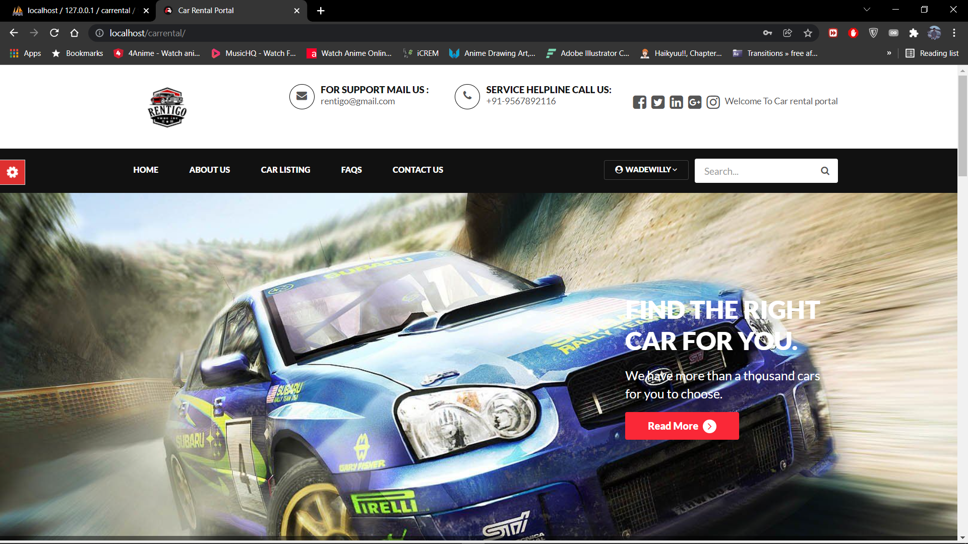

**LOGIN PAGE**

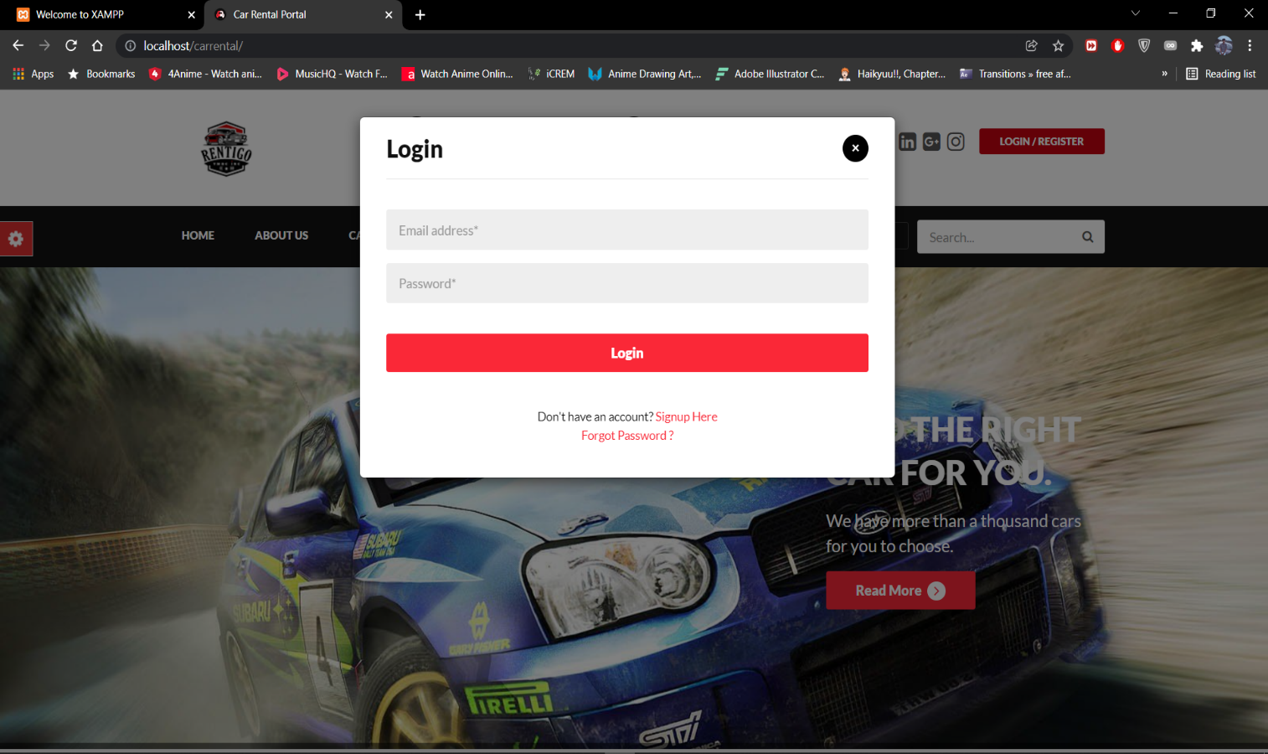

**VIEW VEHICLE**

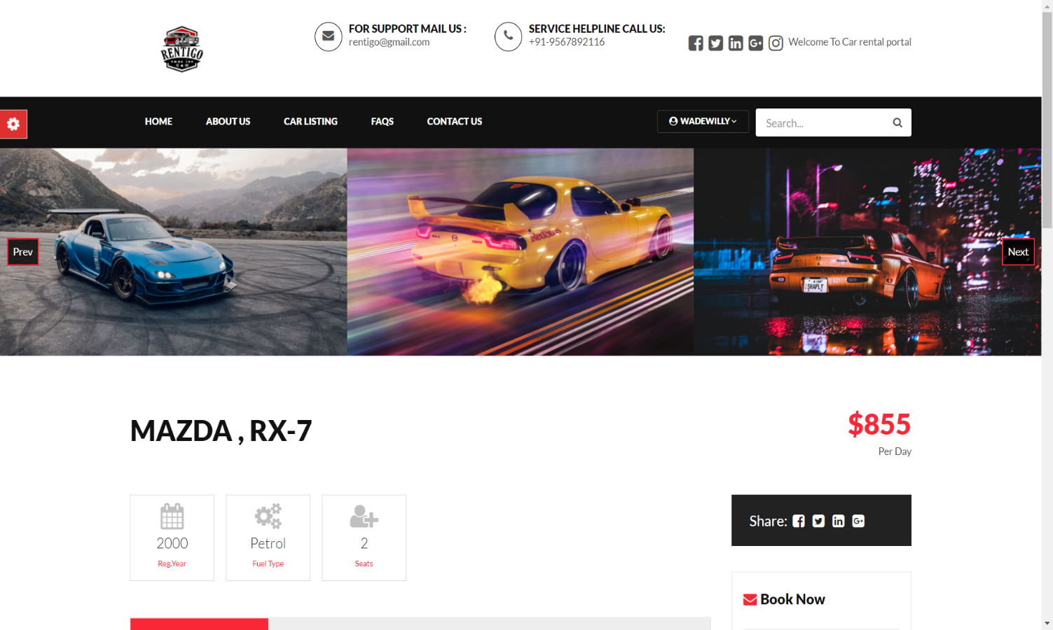

**BOOKING**

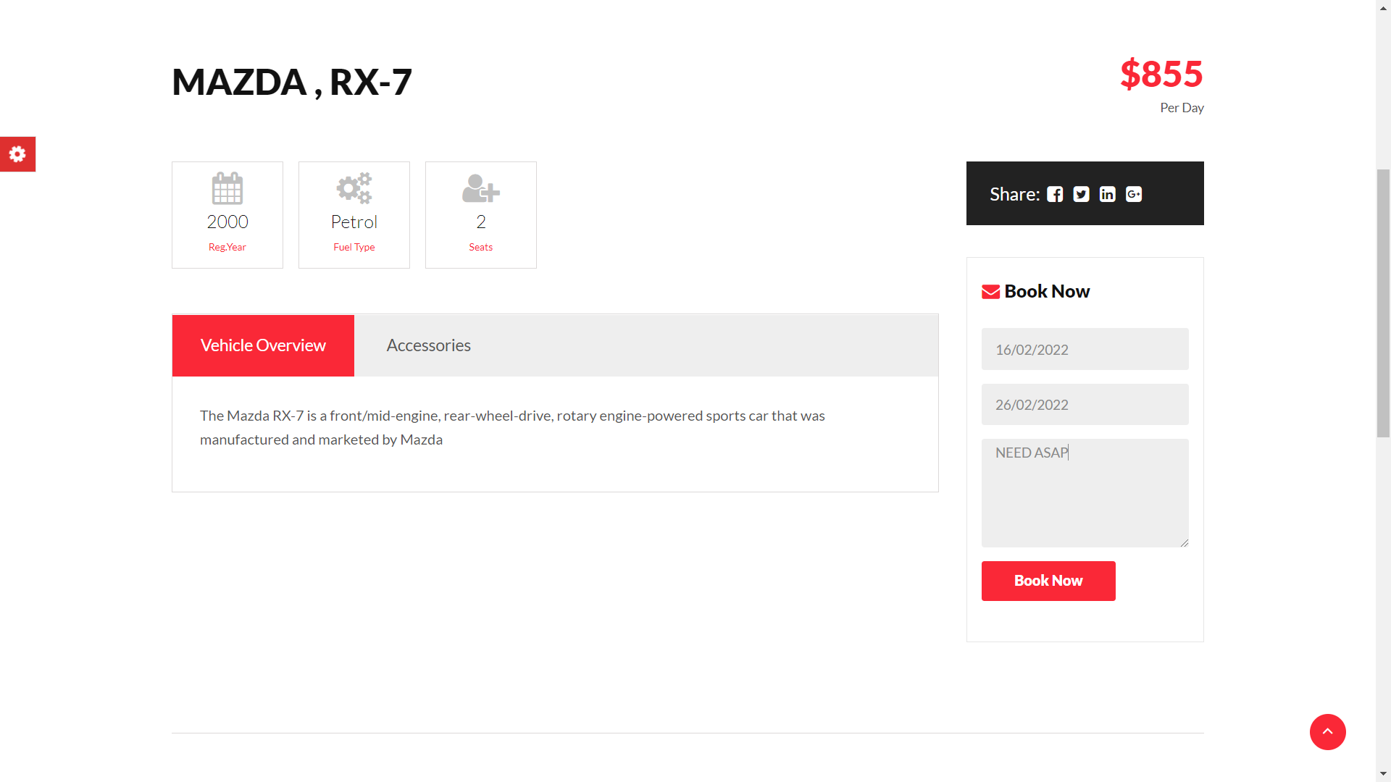

**USER PROFILE**

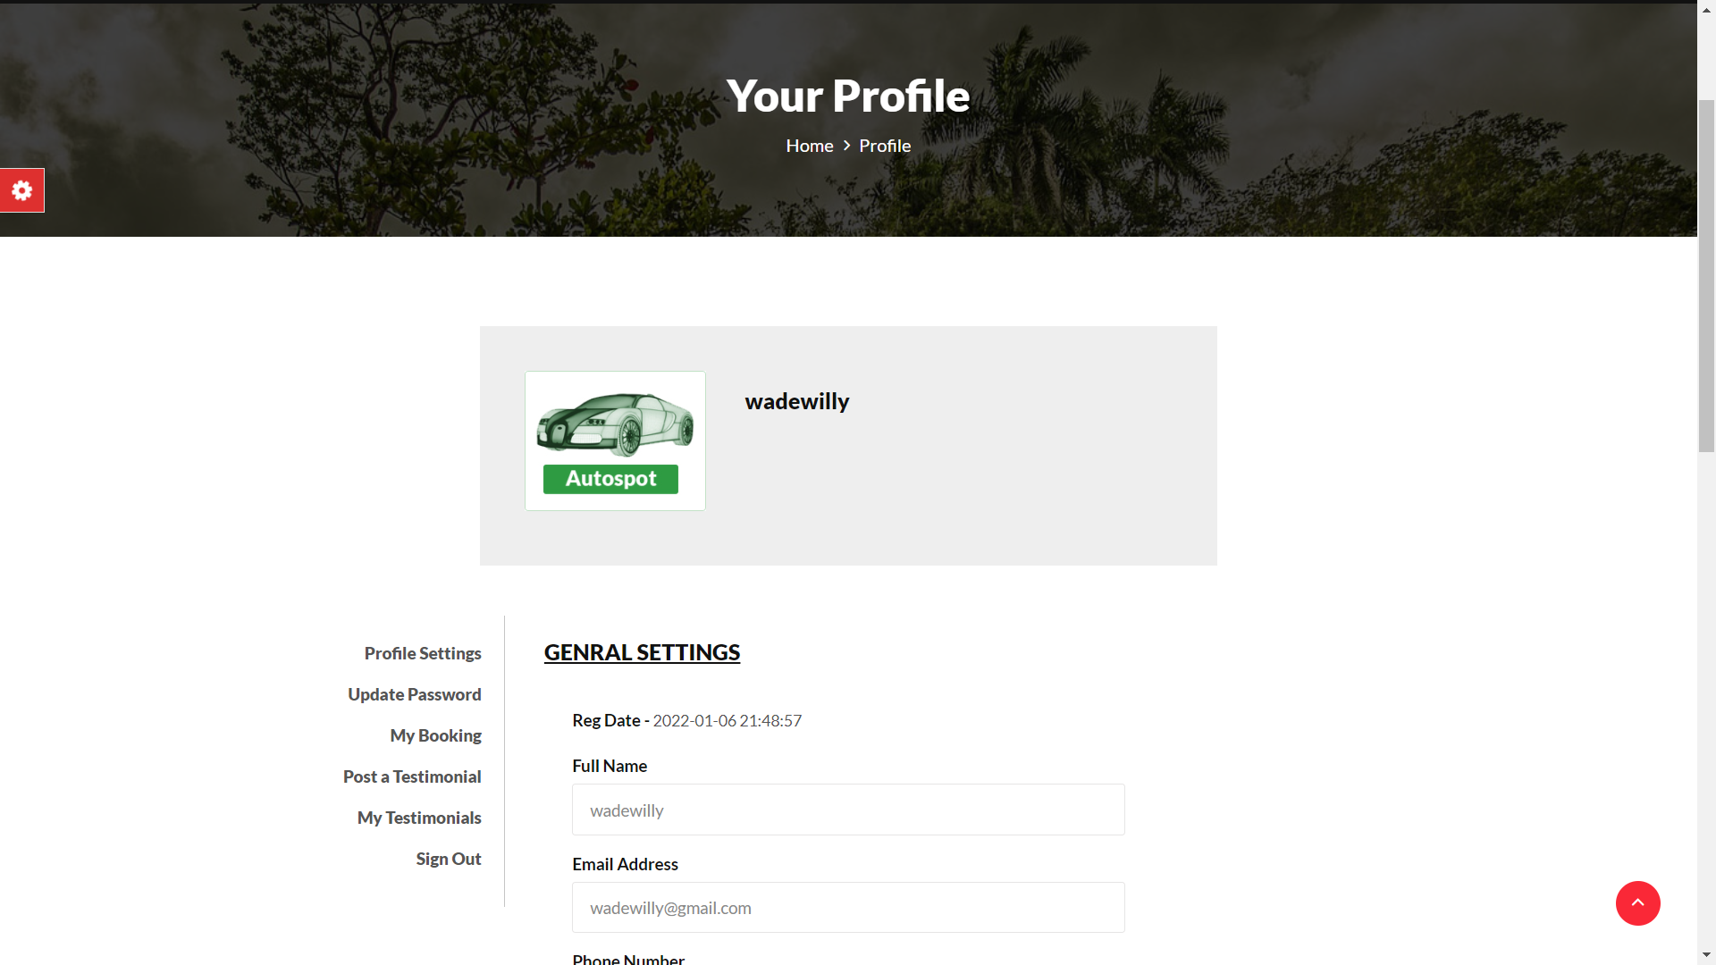

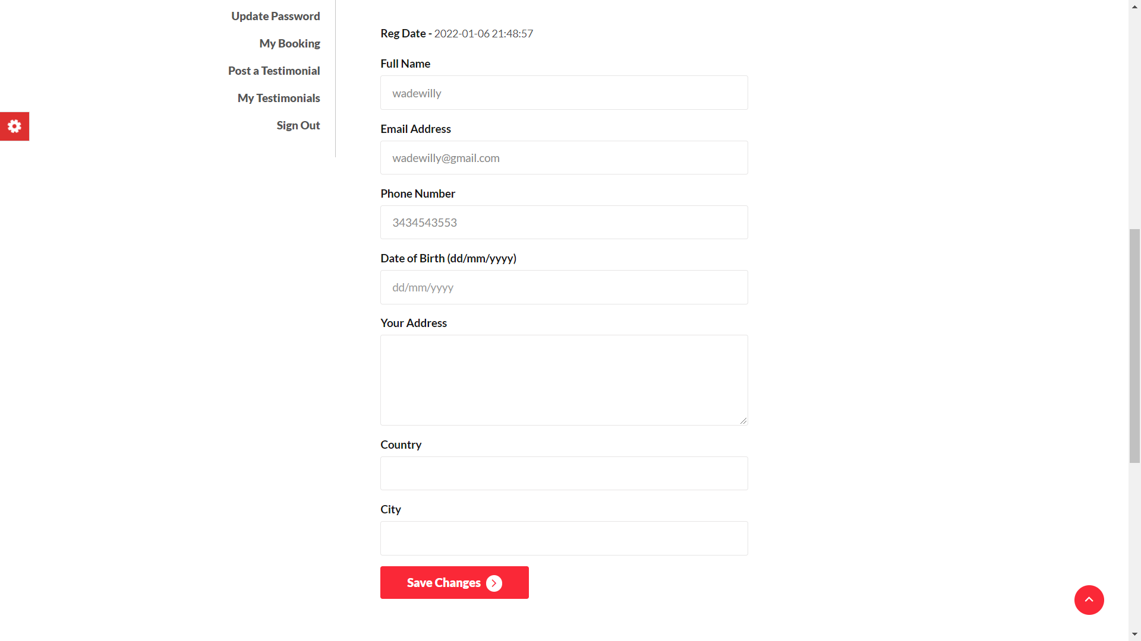

**USER BOOKINGS**

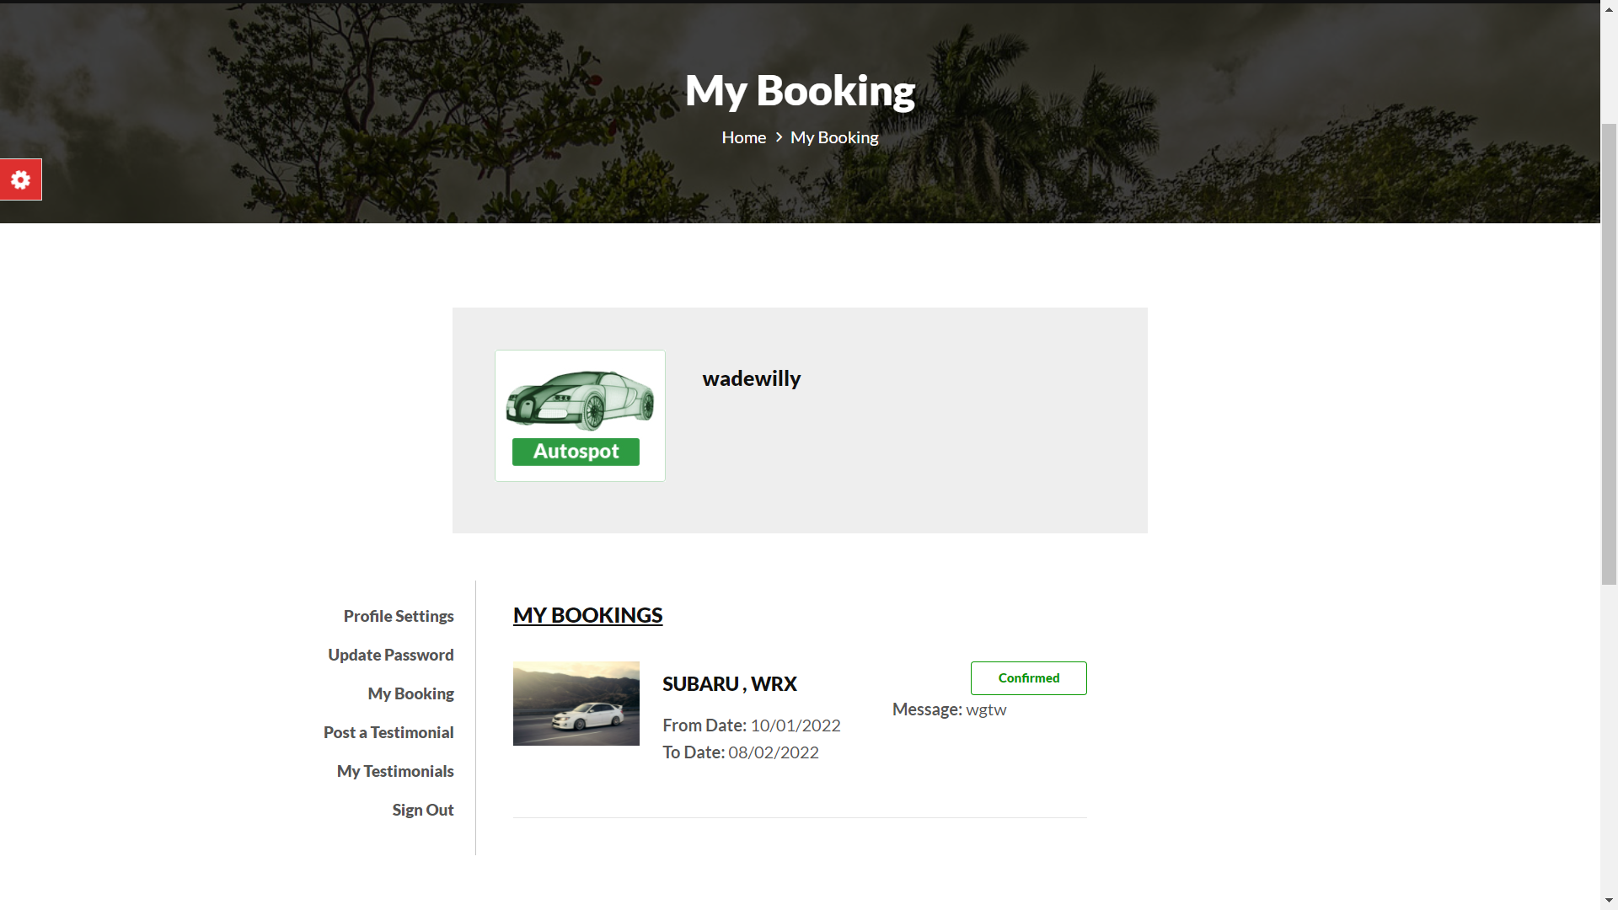

**USER TESTIMONIALS**

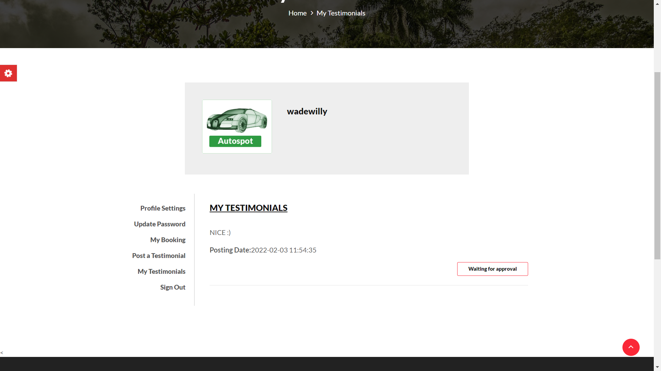

**CONTACT US PAGE**

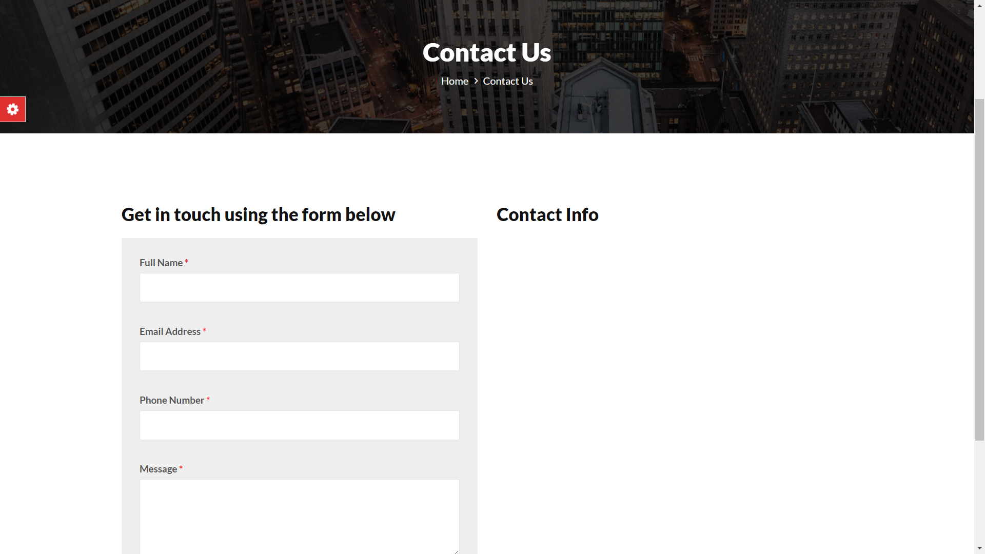

**ADMIN LOGIN**

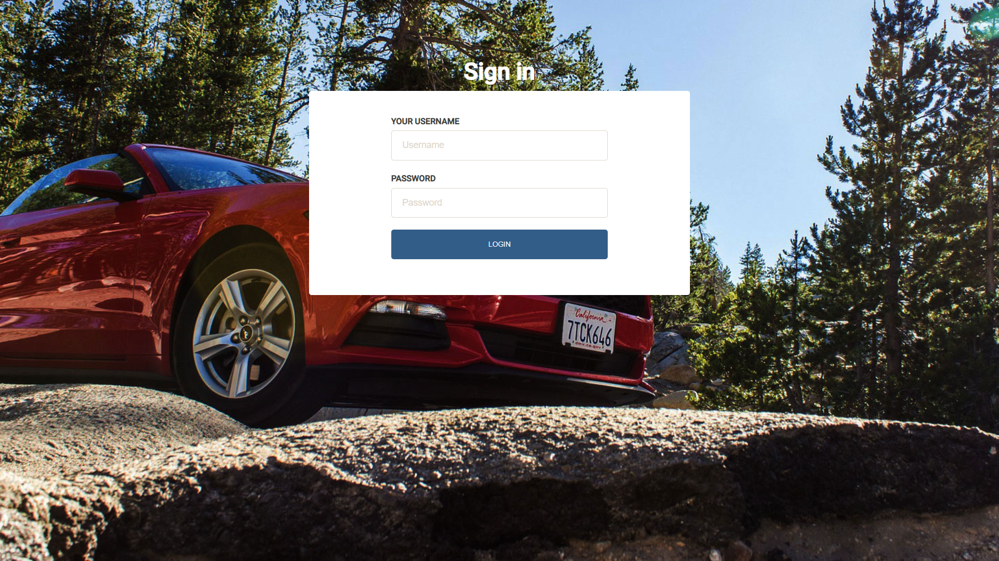

**ADMIN DASHBOARD**

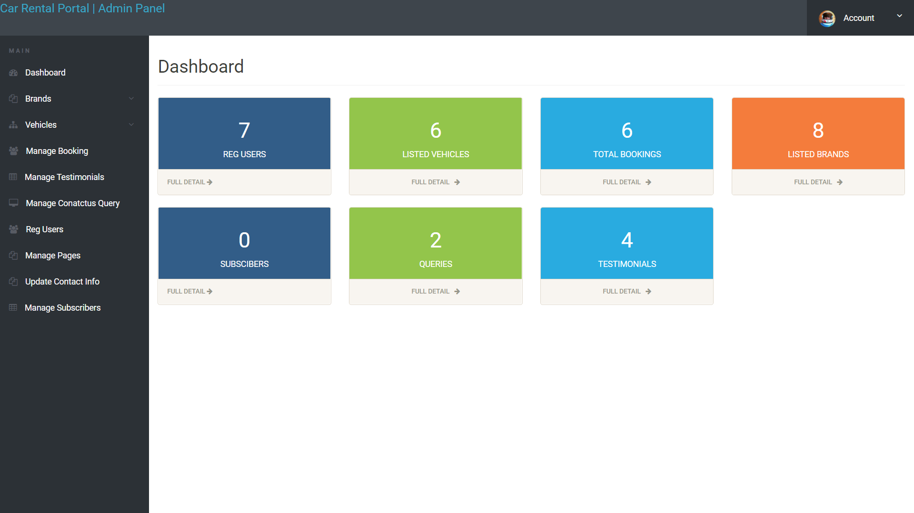

**MANAGE VEHICLE**

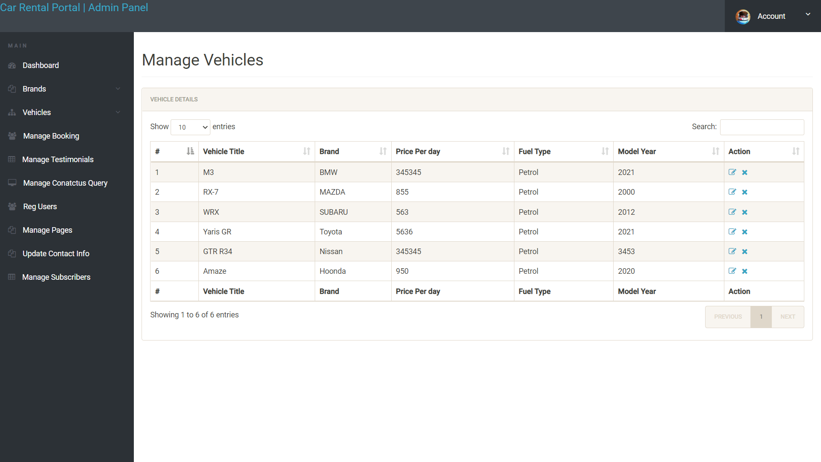

**EDIT VEHICLE INFO/IMAGE**

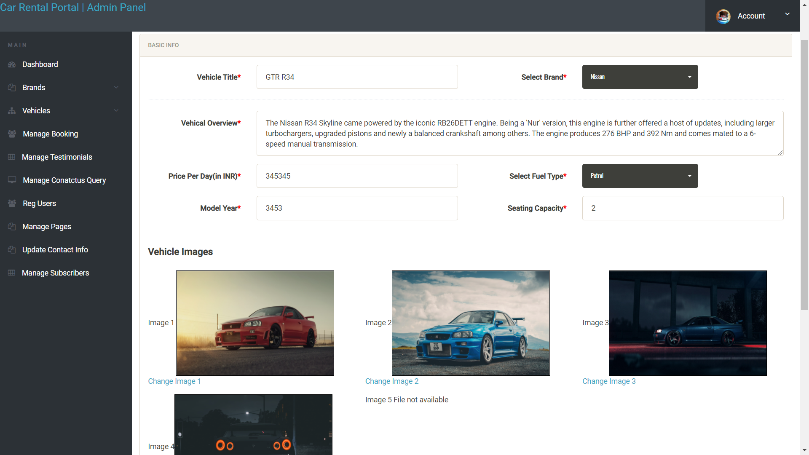

**ADD/REMOVE BRAND**

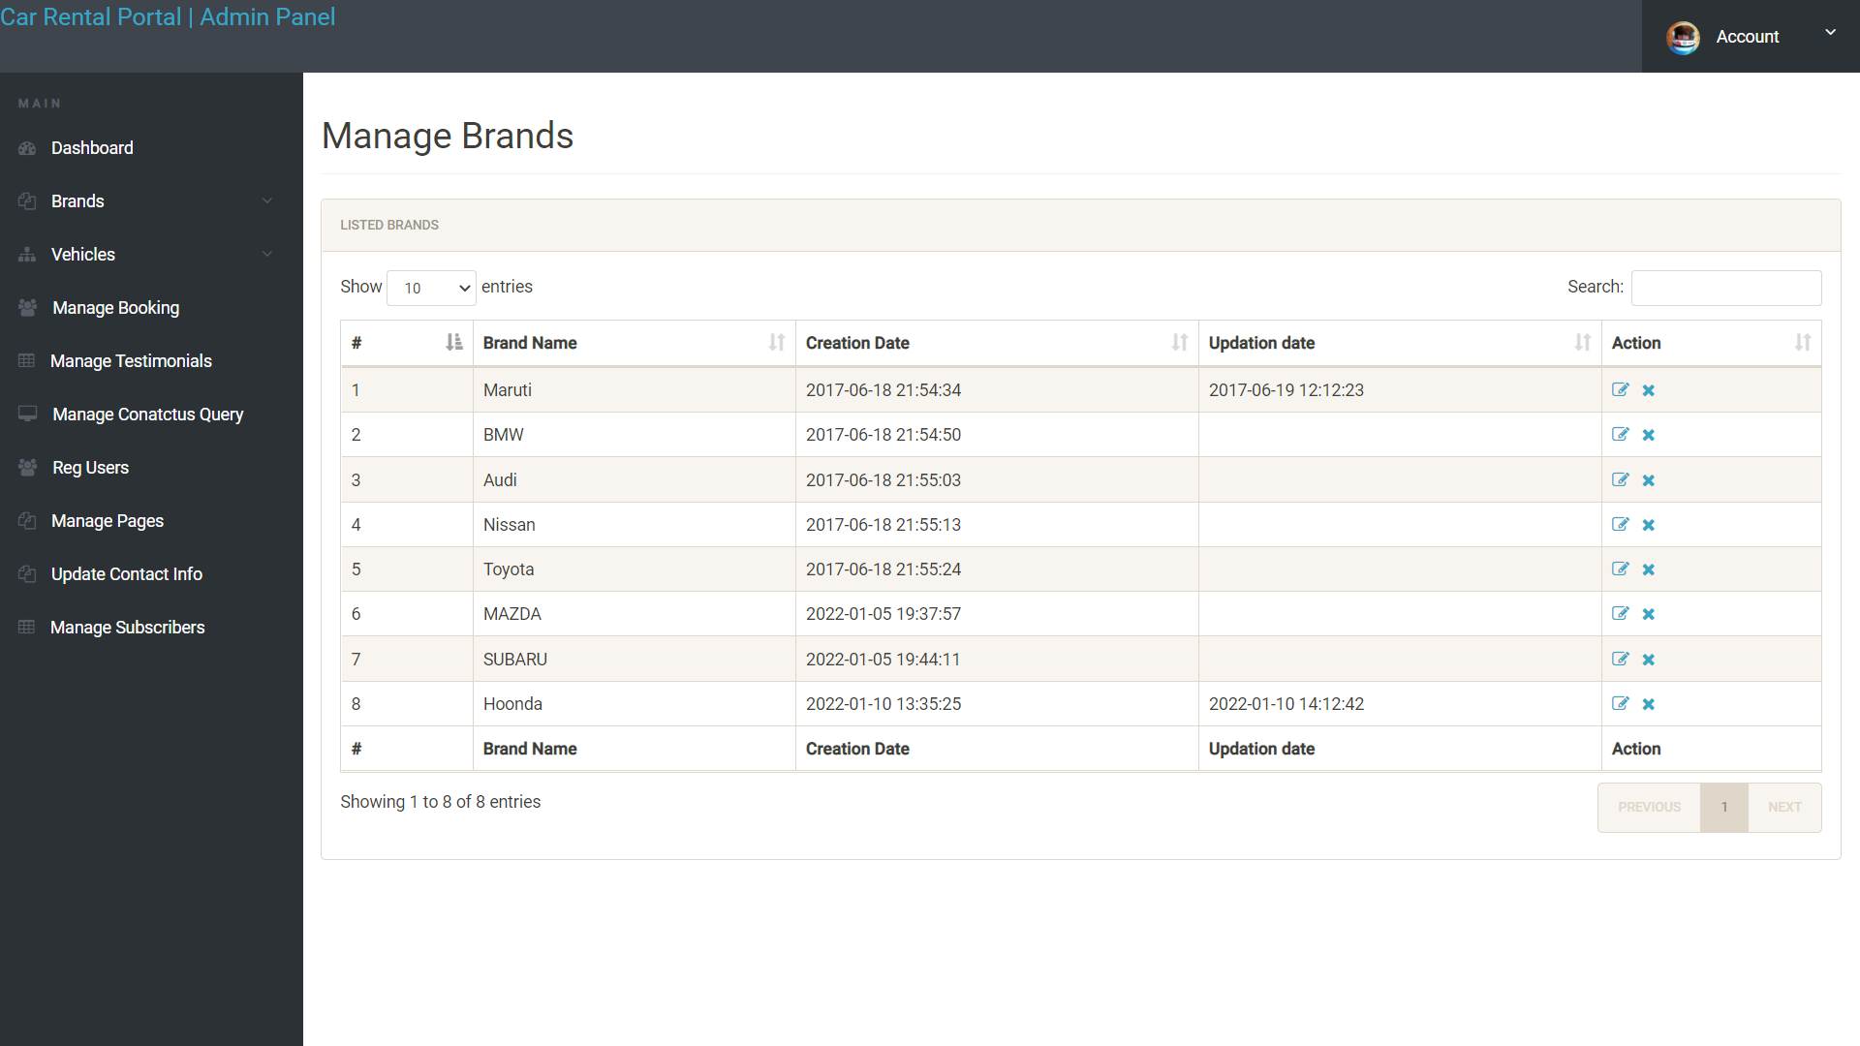

**MANAGE BOOKING**

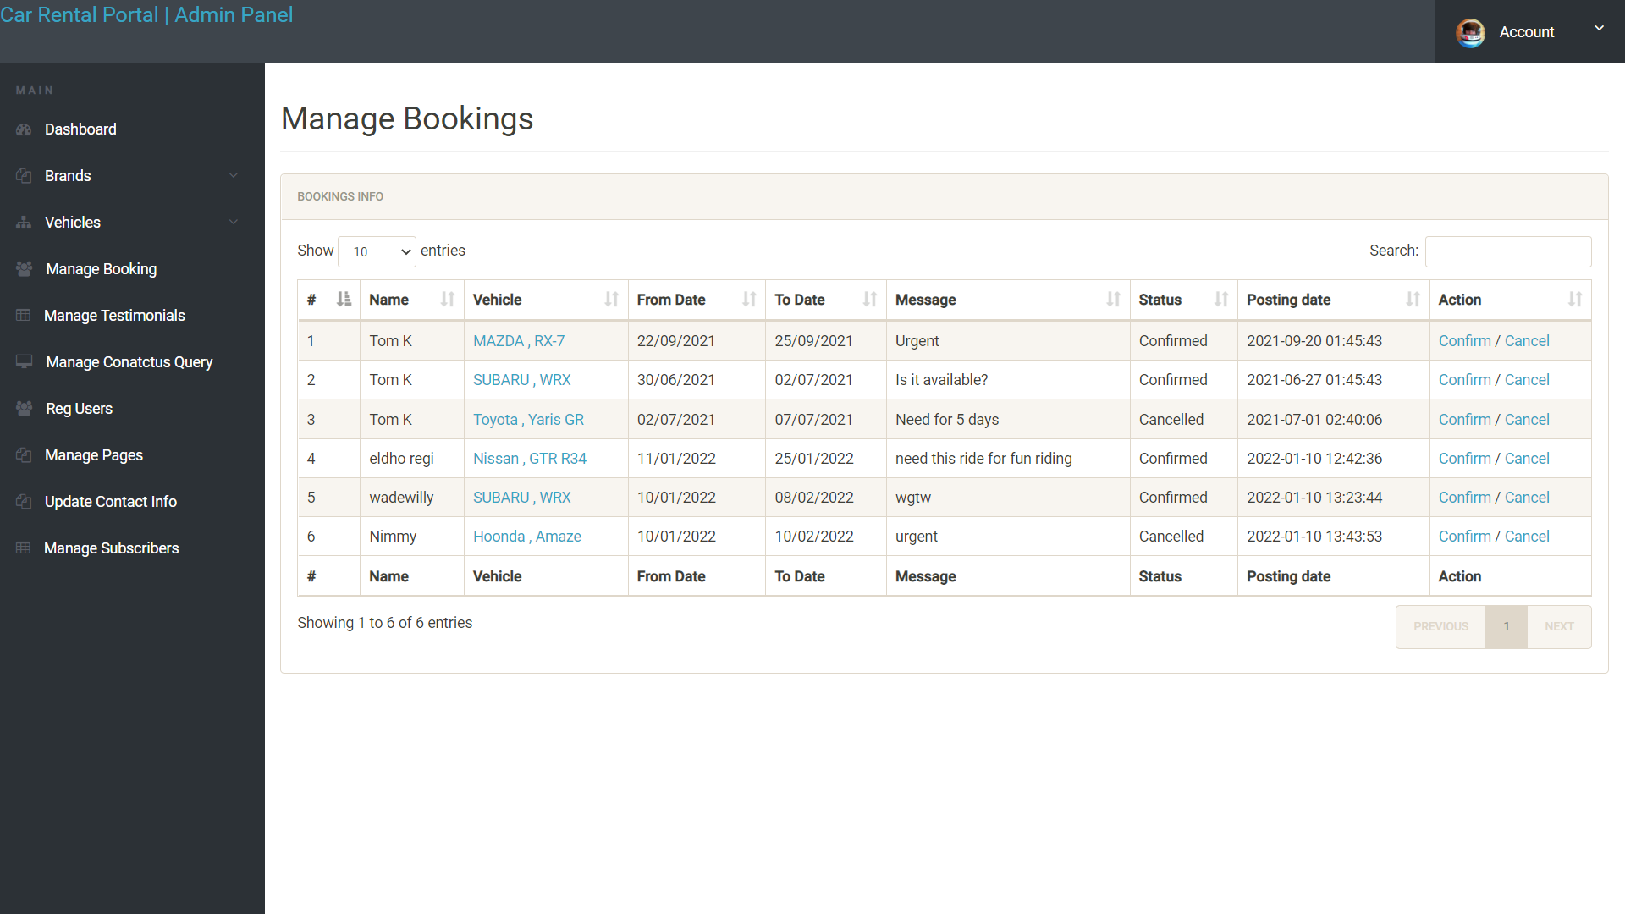

**MANAGE TESTIMONIAL**

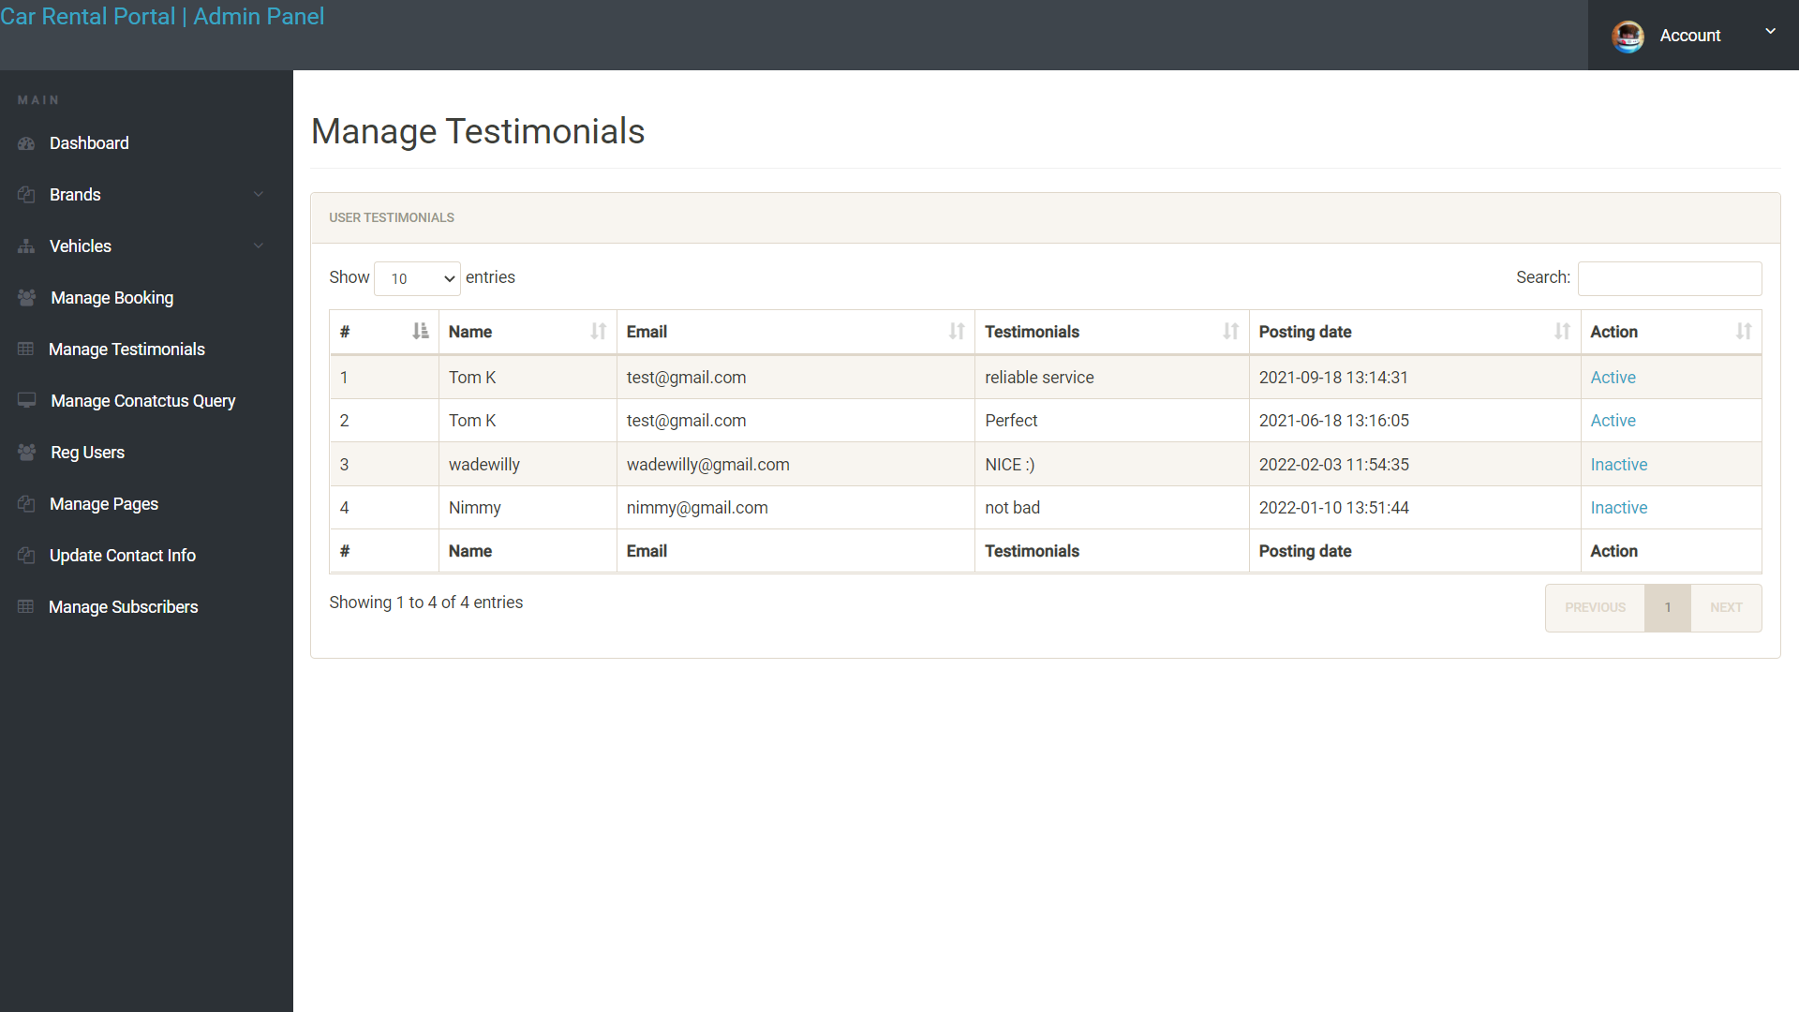

**MANAGE CONTACT US QUERIES**

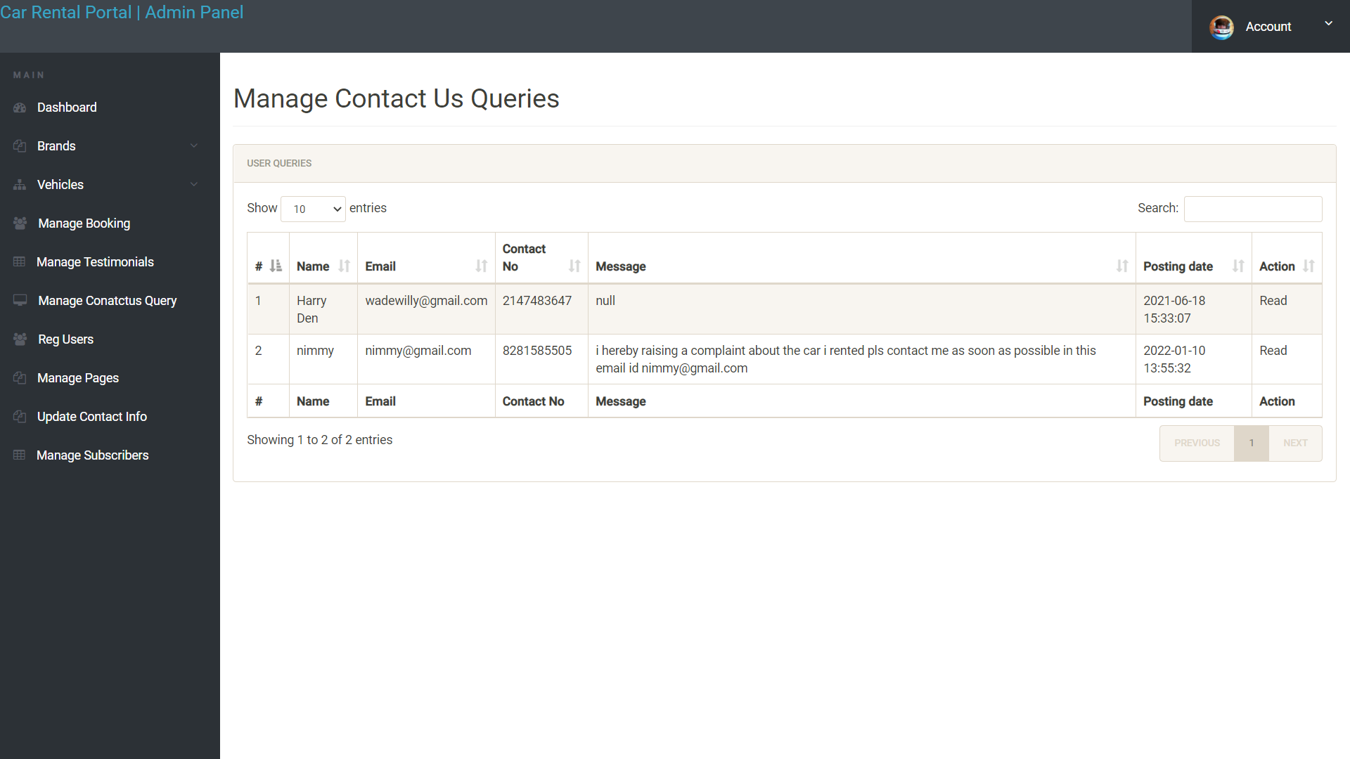

**REGISTERED USERS**

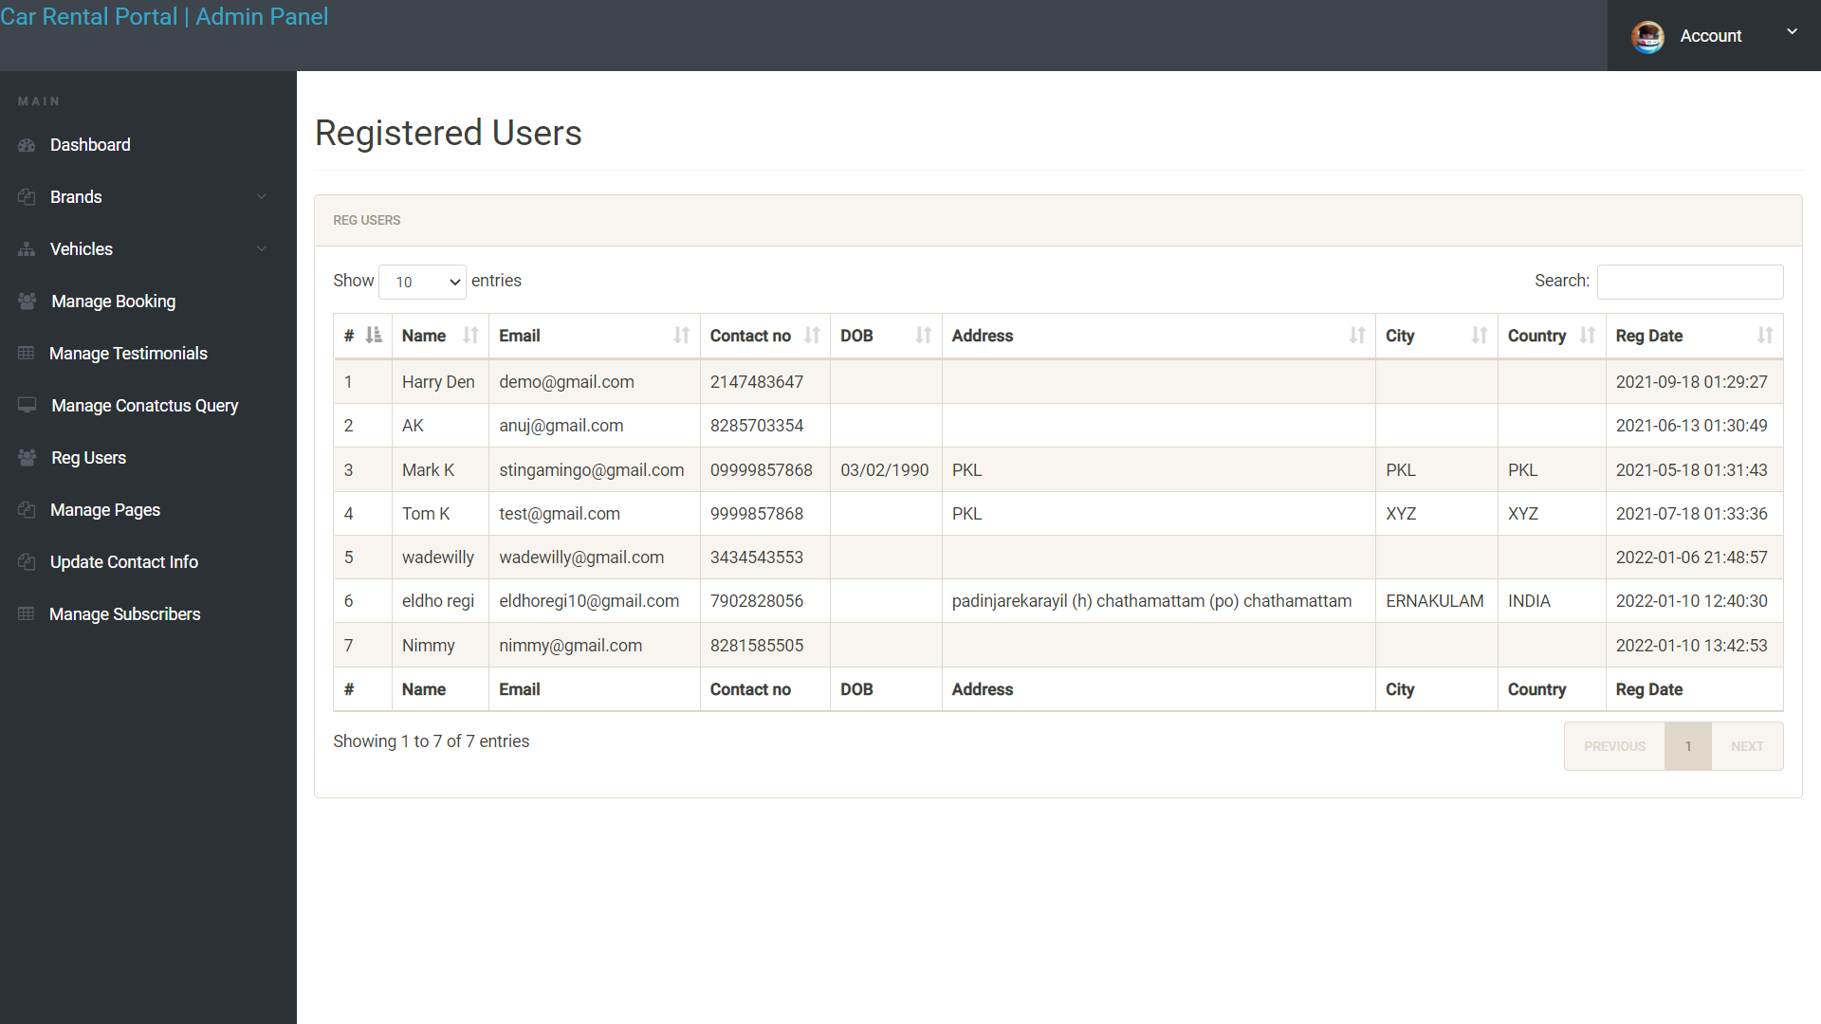

**MANAGE PAGES**

